These notes (labelled as part 1 and 2) are the result of a one hour Auckland workshop organised by the HPA as part of a series of tobacco control seminar in February 2014. The participants were from across a range of tobacco control and health-related organisations, these notes are not indicative of any other smokefree plans or future directions but provide an example of workshopping regional priorities and translating these ideas (part 1) into a tobacco control intervention logic (part 2).

Auckland Regional Public health Service, Northern Regional Authority, The Northland DHB and Auckland regional DHBs are working collaboratively on a regional tobacco control strategy.

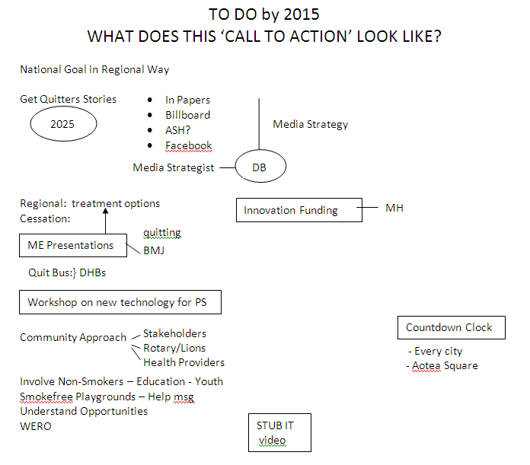
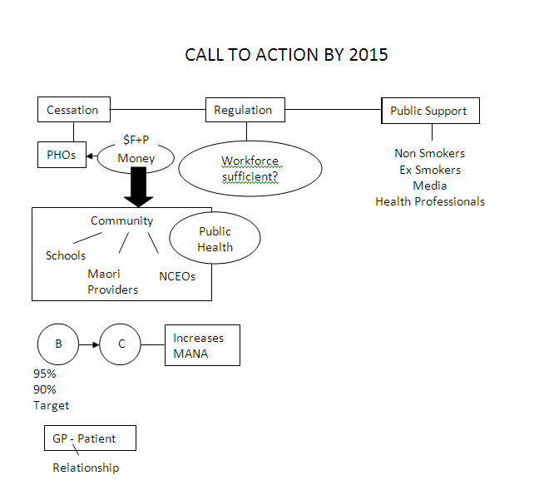
HOW DOES THIS LINK TO THE NATIONAL PRIORITIES
– SMOKEFREE NATION ACTION PLAN 2013-2015?
Community Feedback
Submissions
- Public Support

Templates (Flow charts)
- National/localised data - Key messages
- FAQ – Referenced evidence based
- Menu of issues and how it relates to different groups e.g. Nurses – Pop harm (ownership)
AEIE Mums
- Prompt personal story
- Media releases
- Laymans terms (background)

Tool kits
- Projects examples
- Media releases
- FAQ

SF Iwi
- kaupapa protocols
In terms of journey remind leaders of our responsibility
- AKM
- Settlement phases incl. AK

Workplaces Cessation
- Organisations/workplaces
- Need smokealyzers for Kaimahi Midwives
- SF champions with organisation (HES)

SF Environments
- Streets and outdoor public places
- Questionnaires/surveys
- Rahui
- Extend existing areas
- Raise awareness of local Quit services increase visibility e.g. SF Mall – Quit stall in Mall
- SF signage visible community designed – ownership
- Subcontractors/contractors DHB Health Providers SF Policy

Legislation/Regulation Govt agencies all promoting SF2025 Govt commitment
- WINZ (MSD)
- CYFS
- Budget
- Housing Corp
- Etc.

WHAT TOOLS & RESOURCES DO WE NEED TO MAKE IT HAPPEN?

- More AKP Kaimahi – funding – and trained
- Health Prof/Community involvement/ownership
- Champions
- Self “Policy” incentives to get comm. on board
- Kaumātua & Kuia on board to talk about
- Every Cessation Kaimahi funded to have a “work smokelyser” – particularly midwives to motivate referrals – get engaged
- Free NRT. Inhalers subsidised
- Variety of free NRT options – FREE (GPs too exp. or don’t go)
- Quit Buses to increase access to Quit services
– To take it to the people
TV on Bus!
- To strategically place (Pak ‘n Save, Warehouse, McDs)
- Pop Ups – as above
- Change the Medicines Act – Central Contract to develop
- Smokefree signs for Iwi-Tupeka Kare
- Pay Kamahi to promote
- Venues
- Fast food chains (young people)
- Supermarkets
- Warehouse
Connect with campaign message
High level engagement

WHAT IS AUCKLAND’S/NORTHLAND’S CALL FOR ACTION 2025?

- Tobacco Free Aotearoa
- Completing the 42 submissions being read/supported!!
- Ensure DHB – local govt – iwi involvement (achieve participation collaboration)
- Smokefree cars/playgrounds/restaurants
- Smokefree environment – Papatuanuku
Plain pack tobacco reading tonight!!

WHO IS MISSING FROM THE TABLE?
Reframed this to: Who needs to be at the table?

Health Promotion Agency
Maori Women’s Welfare League
Auckland Council & Northland Councils
National Heart Foundation
Inspiring Ltd
Ringa Atawhai (Aunties project)
Cessation Providers & Quitline
PHOs & DHBs & ARPHS
ASH
Doctors
Pukawakawa (Akld Uni)
Mental Health NGOs
Housing NZ & WINZ
Cancer Society
Rotary
Board Trustees Assoc
Student Councils/Schools
Community houses & leaders
Tertiary Education Providers
Smokers & successful quitters
Health Research Council
Media & Marketers
Maori leaders/Iwi/Marae
Pacific Leaders
Church Leaders
Epidemiologists & strategists
Dental Assoc
Kohanga Reo
Maori Wardens
Smokefree Nurses Aotearoa
SUOI
Police
Youth advocates
Members of Parliament
Hapai
Pharmacies
College of Midwives
Pharmaceutical companies
Nga Maia
Business Associations
Local communities
Budgeting services
Ministry of Health
Lions & Rotary Clubs
Sports trusts/clubs
Girl Guides/Scouts
St Johns
Social Service Organisation
Dept Corrections
Justice – Youth
NZCOSS

Need IT solution for communicating with whole group

