08
Fall

Effective Media Relations
A guide for communities
and organisations

with reference to
World Smokefree Day 2016

Contents
Contents 2
Working with the news media for World Smokefree Day 3
Media Promotion Tips and Advice 4
Getting Started 5
Local Media Channels 6
10 tips for success 7
Tips on drafting a media release 8
Appendix 1: Media release template 9
Appendix 2: Infographic:The Cost of Tobacco 11
Appendix 3: Examples of key messages 12

Working with the news media for World Smokefree Day
World Smokefree Day on 31 May 2016 is a great opportunity to boost awareness and support for the steps towards a Smokefree Aotearoa 2025. The public and media awareness of smokefree is raised at this time, and you can leverage this to highlight a current focus or promote aspects of your smokefree work.

Working with the media can have its risks and challenges but, when managed well, a strong relationship with local media can be incredibly valuable when it comes to boosting awareness of your cause and gaining support for your objectives.

Reporters are always after news – anything novel or different, local stories, data and statistics, new events and issues, slice of life human interest stories etc. If you can help them see the news angle in an issue they’ll generally be interested in covering it
Whatever the situation, and level of experience, this resource offers some tips, templates, and guidelines to help you work effectively with news media.

If you’ve got any questions or require further information contact us at smokefree@hpa.org.nz or go to worldsmokefreeday.org.nz.

Kind regards

The HPA Tobacco Team

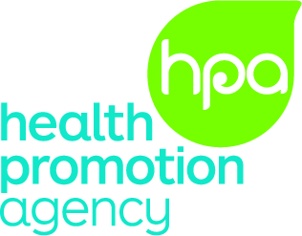

Media Promotion Tips and Advice

Getting organised.

Planning - Plan when and how you want to engage the media. Think about what you want to use the media for and what objectives you want to achieve, ie, is it to promote an event or specific activity, provide comment around a key issue or highlight an important initiative your organisation is doing. You can create greater momentum through regular planned activity rather than just hoping for the best from sporadic, one-off approaches. Let the media know in advance about your article or event as you may need media coverage in the weeks leading up to your event or release of this information.

Sign-off - Ensure the relevant people eg, senior managers, project leaders in your organisation are aware of your media activity and any spokespeople have permission to speak on behalf of their organisation. If possible, have more than one key spokesperson to ensure there are enough people to provide comment and to quote in your article or media release as a credible source. Ensure you brief your spokespeople so it is clear what they need to do and are familiar with the key messages you want to convey. Consider whether there are other organisations/ partners/ stakeholders that you need to inform about the release so if they are approached by the media they are aware and prepared.

Build relationships – Introduce yourself to the local health or general news reporter in your area. Building relationships with reporters is important, it helps to increase opportunities for media coverage and stories. Ask if there are any particular areas of interest or focus they have and, wherever appropriate, invite them to key events and make photo opportunities available.

Getting Started
Think Creatively – Think about what you want to say and the purpose of your article or story and why it’s important. Your information needs to capture the main points succinctly and in an interesting way to grab people’s attention. As a starting point, identify the news angle and the key messages you want to communicate. You could take your story and messages and turn them into a media release and send it out to newspapers or radio stations. Or you could turn it into a Letter to the Editor as they are widely read and published. Alternatively, invite reporters to come out and cover the story in person or conduct an interview. You can also approach the newspaper about contributing to a column or placing an advertorial (which is a combination of an article and advertisement that you pay for).
Before writing a release or making contact brainstorm any potentially difficult questions and prepare responses for these. This will help to manage any risks and to ensure you are well prepared.
Contacting the media –You’ve got your key messages, you’ve got an exciting news angle and you can tell anyone the purpose of the story in two sentences. What next?
Contact your local media and tell them about your story/event. Tell them what you’re trying to achieve, why it’s important and/or topical and a good idea to cover your event/story. Make it worthwhile and easy for them. Follow up the call by sending information about your event.
Try this approach:
“Hello/Kia ora, this is (name) from (organisation). Have you got a moment to talk about (World Smokefree Day) or (people in xx region who are quitting smoking)?
Yes – “Great, I think there’s a great local angle and story here with some recent local figures and a perfect photo opportunity. We can provide a release or invite you to pop in. How would you prefer to approach it?”
No – “that’s fine. When would be a good time to call back?”

Photo opportunities - It helps if you have a photo to back up your story to attract the reader’s attention. Think about how your story/event will be interesting in terms of photo opportunities and call the local newspaper and invite their photographer to attend or offer to send a photo and a media release if they can’t make it.

Local Media Channels
Local print media - These can be as big as a daily newspaper or as small as the free weekly community papers. There are a number of ways that you can get your information into the newspaper. It could be via a media release, a story or interview that the journalist prepares, Letter to the Editor or contributing to a column. You can also place an advertisement, advertorial or insert into the newspaper (there is a cost for this). Advertising is better for promoting an activity/event or drawing attention to a particular cause.

Local broadcast media - Includes regional television and radio (commercial, community and student), Iwi and Pacific. Ensure your audience is reading, viewing or listening to this media as there is no point in putting all of your effort, and/or budget, into publicising or advertising through a channel if it’s not going to be seen or heard.

Community notice boards and newsletters - Send a short paragraph or summary covering the main points of your story (who, what, when, where, why and how) to your newspaper, internet and radio community diary/noticeboard. Ask about the maximum word length and stick to it. Staff, school or workplace newsletters can also be great vehicles for messages.

Who else may be interested - Not only the health reporter may be interested. If you are doing a specific event, remember the general news reporter might be keen to cover it as a feature story. Always send your release to the chief reporter as well.
Other media channels – There are other free or cost effective channels that you can use to get your information, and/or messages into the community.
- Talk to your local council about how they could help, often you can display posters, signage or banners on council-owned land, buildings or fences. They may also have other channels you can use such as bus adshels, poster and billboard sites.
- Local businesses and retailers may have window space or notice boards that you can use to display information. Supermarkets, large retailers, pharmacies and hardware shops are a good place to start.
- Approach local bus companies as some of them have space available inside the buses to display posters.
- Posters can be put up around key locations or highly visible areas in your community – you may need to approach the council or go through a poster/promotions company who will charge for this.

10 tips for success

- Key Message/s - Stick to your key messages (3 to 4 is enough) and repeat them. Remember, an event itself isn’t the ‘reason’ for a story. What is the purpose and/or message behind the event – use the event to highlight that issue or cause.
- Be succinct - Before drafting a release or doing an interview, see if you can convey your key messages in two sentences. If you can do that, you’re ready. Give the media phrases they can pick up and use straight away (short, snappy quotes in everyday language, metaphors and humour where appropriate) – they’ll be less likely to rewrite your words.
- Accuracy - Check all communications for spelling and grammar errors. Be careful to write abbreviations out in full, for example, write World Smokefree Day, not ‘WSFD’.
- Use data - Figures and stats help put a story in context and give people a sense of the scale of an issue. News media love them. Make sure they are relevant and correct though.
- Say what you know - If you’re asked about something you don’t know, just say so and offer to find out.
- Plain English - Use plain English only (i.e., instead of “NRT” say “patches,” instead of “methodology” say “method” or “approach” etc).
- Keep cool - Remain professional and keep coming back to your key messages. This doesn’t mean you can’t disagree or correct statements, but do so firmly and clearly.
- Be helpful - It is almost always better to comment than to say nothing. If you can’t, say so and offer suggestions for who can.
- Be responsive - If the media respond, get back to them fast because they work to tight deadlines. Ensure there is a second contact person if you aren’t always around to take calls
- Be reliable - Always provide contact details of a spokesperson and ensure the details are correct and that they are the right person to speak on the topic or on behalf of an organisation. Ensure they are prepared and available for media calls.

Tips on drafting a media release
Use these tips to help write an effective media release.
The triangle approach: lead with the key details and key quotes – anything lower down is likely to get edited out. Make the opening lines succinct and punchy.
Write your release just like a news story would appear in the paper (have a look at some, copy the style).

Minor points might get edited!

Key points at the top!

A common formula/template works like this:
  - Heading – Find a catchy angle that matches the story.
  - Short, punchy intro – Convey the key facts and the point of the story in one paragraph. Then develop it over the following quotes and paragraphs.
  - Quotes – Put quotes from key people early in the release. This keeps the story feeling active, and alive.
  - Supporting information - After the initial quote/s add one or two paragraphs of supporting information to provide background people need to know.
  - Further quotes – Adding another punchy quote here can help keep the reporter engaged with your whole release and use more of your story.
  - Close with any last details – i.e. if the story is about an event, list where and when etc. This is the place to direct people to sources for more information etc.

The Health Promotion Agency is preparing a set of media releases to support you in your media relations work this World Smokefree Day. The first of these is included below and is also available at worldsmokefreeday.org.nz. These media release templates are designed for you to insert local information and quotes to make them relevant for the communities you are working in.

Appendix 1: Media Release Template
For those who want to engage local media, the following media release template is provided. It contains sections where you can insert local information to tailor content relevant to your community. This release can then be sent on to media. Further media release templates will be provided prior to World Smokefree Day 2016.

[HEADLINE OPTIONS]

Food and groceries weigh in against tobacco on World Smokefree Day
Tobacco outweighs the costs of food and groceries
Tobacco adds pressure to the cost of living

The cost of living is not getting any cheaper in New Zealand. When tobacco addiction is added in to the mix the challenge to pay bills and keep food on the table is that much harder.

Quitting smoking saves you money and for so many [insert region/city/town] families, staying ahead of the bills and keeping food on the table is a real challenge. For the 15% of New Zealanders that smoke the pressure can be even greater.

“For an average 10-a-day smoker, you’re looking at over $50 a week, $250 a month or $3000 a year going on smoking, this is a lot of money and it quickly starts to add up” [NAME] explains.

“That’s a block of cheese and two litres of milk, or public transport costs covered, each day – an extra tank of gas each week, your monthly phone and power bills combined or a trip to Australia and back for a family of four each year,” [NAME] adds.

May 31 is World Smokefree Day and [NAME or Name of local DHB/PHO] is encouraging smokers to make the most of the occasion and quit for good. The focus for this year’s World Smokefree Day is about quitting now and whānau taking control by supporting and encouraging each other to make it happen.

For those who decide the time is right to quit, there’s more help available than ever. [Insert information about local service/s and Aukati KaiPaipa here as relevant].

Services like Quitline provide a free service to quit smoking offering a quit pack and support over the phone, online and by text. There is also an increasing range of medical products and nicotine therapies available, from as little as $5 per product for an 8-week supply.

“World Smokefree Day is the perfect opportunity to quit. Trade in the smokes for a full tank of gas – literally and figuratively. Or pick up another loaf of bread, some milk and some cheese instead of that cigarette packet,” [NAME] urges.

“It’s about freedom. It’s about whānau and being there for those you love. Take up the challenge and take a step towards a smokefree Aotearoa and quit smoking on 31 May, World Smokefree Day.”

For help and support to quit smoking, contact your local health provider or doctor?, Aukati KaiPaipa service [NUMBER] or Quitline (0800 778 778 or www.quit.org.nz).

For more information please contact [name, organisation, contact details].

ENDS

Notes to reporter:

- For more information on World Smokefree Day, go to: www.worldsmokefreeday.org.nz
- World Smokefree Day was created by the World Health Organisation in 1987. In other countries it is known as World No Tobacco Day.

Appendix 2: Infographic:The Cost of Tobacco

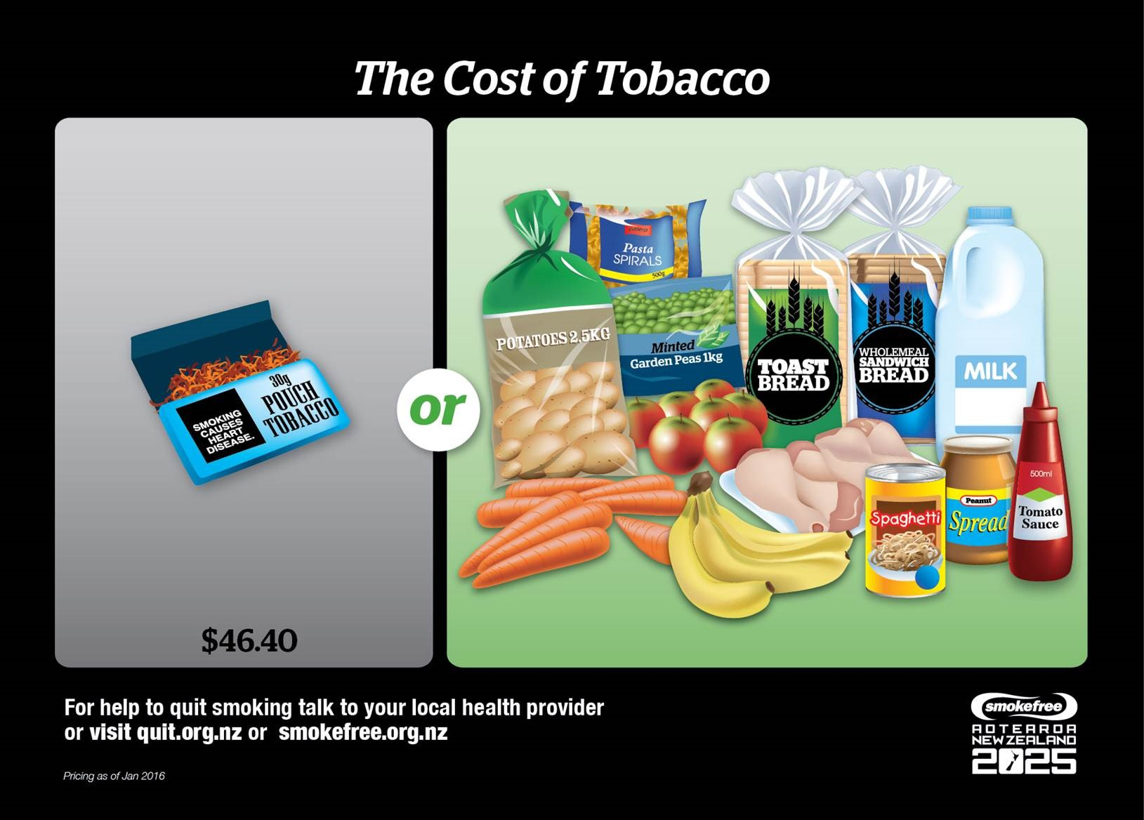

To download for local use, please click visit http://smokefree.org.nz/2016-tools-resources

Appendix 3: Examples of key messages
Key messages are core or critical messages that can be used to communicate about World Smokefree Day. They provide context and meaning about World Smokefree Day and enable communications to be consistent and accurate. These messages can be broadly used across a range of material in relation to World Smokefree Day.

World Smokefree Day key messages

- Created by the World Health Organisation (WHO) this global event is celebrated annually on 31 May and is called World No Tobacco Day. In New Zealand it is known as World Smokefree Day.

- The purpose of World Smokefree Day is to inform people about the dangers of using tobacco and what people can do around the world to claim their right to health and healthy living to protect future generations.

- In New Zealand World Smokefree Day is about celebrating and working towards smokefree/auahi kore lives for New Zealanders.

- World Smokefree Day increases awareness of the steps we can take to be smokefree to achieve the Smokefree 2025 goal.

- The theme for 2016 World Smokefree Day is ‘Quit now. It’s about whānau.’ It’s about encouraging and supporting those who want to quit smoking creating environments where our children are free from exposure to tobacco.

- World Smokefree Day provides an opportunity to stand together as a family or a community to encourage and support each other to protect the health of our future generations.

